**Oncology**

**Brief Introduction [1]**

**Oncology** is a branch of medicine that deals with the prevention, diagnosis, and treatment of ‘cancer’. A medical professional who practices oncology is an *oncologist*.

Cancer survival has improved due to three main components: improved prevention efforts to reduce exposure to risk factors (e.g., tobacco smoking and alcohol consumption), improved screening of several cancers (allowing for earlier diagnosis), and improvements in treatment

**What is Cancer [2]**

Throughout our lives, healthy cells in our bodies divide and replace themselves in a controlled fashion. Cancer starts when a cell is somehow altered so that it multiplies out of control. A tumour is a mass composed of a cluster of such abnormal cells.

Most cancers form tumours, but not all tumours are cancerous.

Benign, or noncancerous, tumours do not spread to other parts of the body, and do not create new tumours. Malignant, or cancerous, tumours crowd out healthy cells, interfere with body functions, and draw nutrients from body tissues.

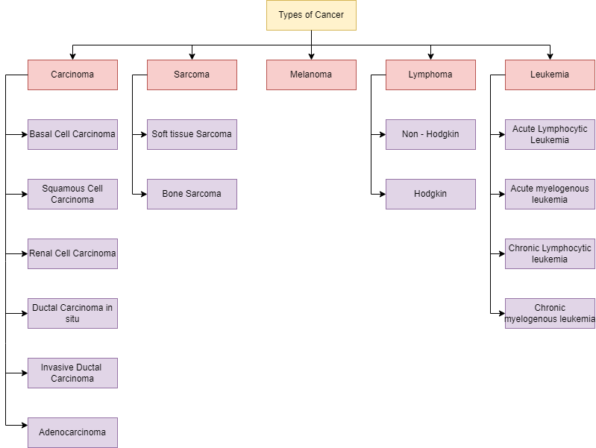

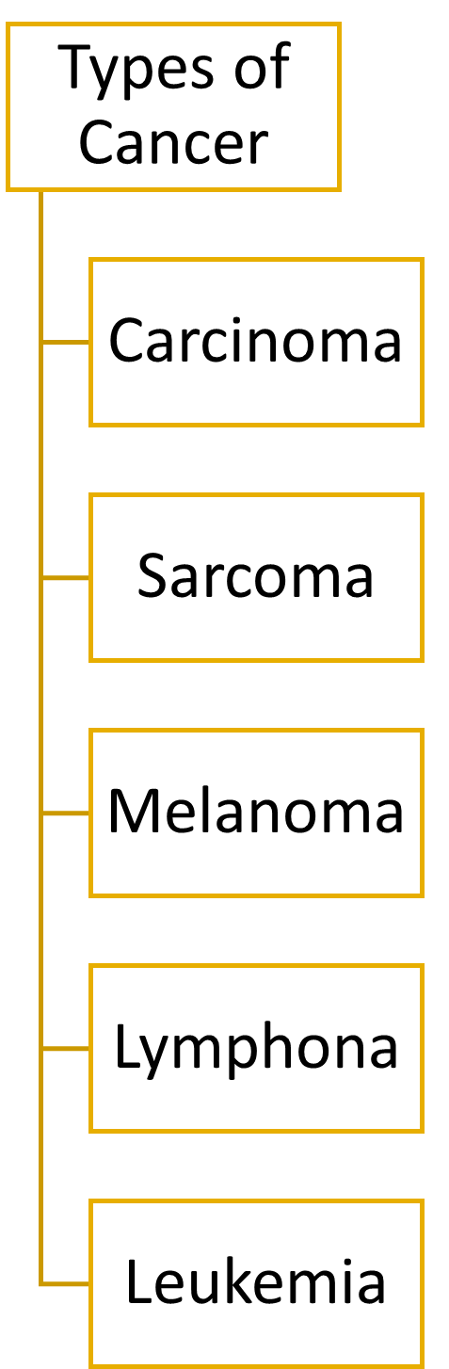

Carcinoma is a type of cancer that starts in cells that make up the skin or the tissue lining organs, such as the liver or kidneys. [3]

A sarcoma is a rare kind of cancer. Sarcomas grow in connective tissue -- cells that connect or support other kinds of tissue in your body. These tumours are most common in the bones, muscles, tendons, cartilage, nerves, fat, and blood vessels of your arms and legs, but they can also happen in other areas of your body. [4]

Melanoma is a disease in which malignant (cancer) cells form in melanocytes (cells that color the skin). Melanoma can occue anywhere on the skin. [5]

Lymphoma is cancer that begins in infection-fighting cells of the immune system, called lymphocytes. These cells are in the lymph nodes, spleen, thymus, bone marrow, and other parts of the body. There are two main types of Lymphoma: Non-Hodgkin and Hodgkin. [6]

Leukemia is a blood cancer caused by a rise in the number of white blood cells in your body. Those white blood cells crowd out the red blood cells and platelets that your body needs to be healthy. The extra white blood cells don’t work right. [7]

1. **Carcinoma**

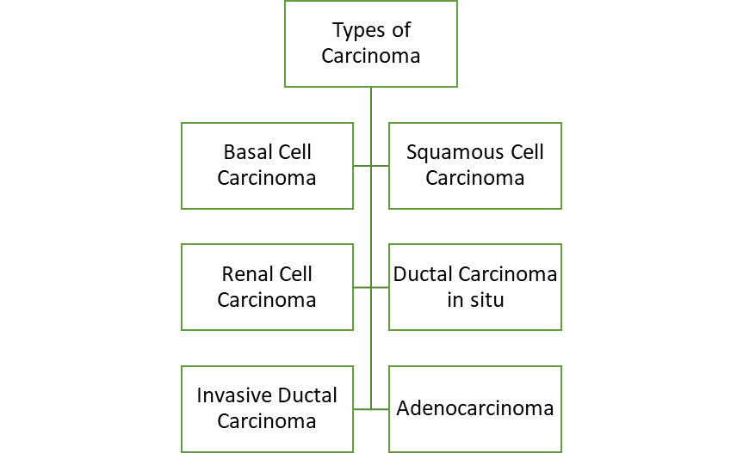

* 1. **Basal Cell Carcinoma**

This is the most common form of all cancers. It occurs in cells lining the deepest part of the skin's outer layer. One should get quick treatment for basal cell carcinoma to avoid scars. [3]

Basal cell carcinomas often look like: [3]

* Open sores
* Red patches
* Pink growths
* Shiny bumps or scars
  1. **Squamous Cell Carcinoma**

SCC is a type of skin cancer that grows in squamous cells. These are flat, fish-scale-like cells that line the skin and inside of hollow organs, such as the cervix and vagina. As with BCC, SCC tends to grow in areas of the skin that are frequently in the sun such as: [3][8]

* Face
* Ears
* Neck
* Lips
* Backs of the hands
  1. **Renal Cell Carcinoma**

This is the most common type of kidney cancer. It usually grows as a single tumor within the kidney. Renal cell carcinoma is sometimes discovered when you have a CT scan or an ultrasound for another reason. Sometimes it is detected after it has already become very large or spread to other organs. [3]

* 1. **Ductal carcinoma in situ (DCIS)**

This is a condition where cancer cells are found inside the ducts of the breast. But in DCIS, the cancer has not fully developed or spread into nearby areas. Nearly all women diagnosed with this can be cured. [3]

* 1. **Invasive ductal carcinoma**

This type of breast cancer starts in a milk duct but spreads into the fatty tissue of the breast. It can spread to other parts of the body through the lymph system and bloodstream. [3]

* 1. **Adenocarcinoma**

This is a type of carcinoma that starts in cells called "glandular cells." These cells make mucus and other fluids. The glandular cells are found in different organs in your body. [3]

Adenocarcinomas can occur in different parts of the body. Some examples of cancers that can be adenocarcinomas include lung, pancreatic, and colorectal types. [3]

1. **Sarcoma**

A sarcoma is a rare kind of cancer. Sarcomas are different from the much more common carcinomas because they happen in a different kind of tissue. Sarcomas grow in connective tissue -- cells that connect or support other kinds of tissue in your body.

Although there are more than 50 types of sarcoma, they can be grouped into two main kinds: *soft tissue sarcoma and bone sarcoma*, or osteosarcoma. [9]

* 1. **Risk Factors**

The causes of Sarcoma are not yet clear, but some things have been discovered that raise the risk of developing one:

* Other people in the family have had sarcoma
* One has a bone disorder called Paget's disease
* One has a genetic disorder such as neurofibromatosis, Gardner syndrome, retinoblastoma, or Li-Fraumeni syndrome.
* One has been exposed to radiation, perhaps during treatment for an earlier cancer.
  1. **Risk Factors**

We don't yet know what causes sarcoma, but we do know some things that raise the risk of developing one: [9]

* Other people in your family have had sarcoma
* You have a bone disorder called Paget's disease
* You have a genetic disorder such as neurofibromatosis, Gardner syndrome, retinoblastoma, or Li-Fraumeni syndrome
* You've been exposed to radiation, perhaps during treatment for an earlier cancer.
  1. **Symptoms**

Soft tissue sarcomas are hard to spot because they can grow anywhere in your body. Most often, the first sign is a painless lump. As the lump gets bigger, it might press against nerves or muscles and make you uncomfortable or give you trouble breathing, or both. There are no tests that can find these tumours before they cause symptoms that you notice.

Osteosarcoma can show obvious early symptoms, including:[9]

* Pain off and on in the affected bone, which may be worse at night
* Swelling, which often starts weeks after the pain
* A limp if the sarcoma is in your leg
  1. **Diagnosis**

If your doctor thinks you may have a sarcoma, you'll probably need a full exam and tests, including:[9]

* A sample of cells from the tumour, called a biopsy
* Imaging tests, such as a CT scan, an ultrasound, or an MRI, to help see inside your body
* A bone scan if you might have osteosarcoma
  1. **Treatment**

How your sarcoma is treated depends on what type you have, where in your body it is, how developed it is, and whether or not it has spread to other parts of your body, or metastasized.

Surgery takes the tumour out of your body. In most cases of osteosarcoma, the doctor can remove just the cancer cells, and you won't need your arm or leg removed, too.

Radiation can shrink the tumour before surgery or kill cancer cells that are left after surgery. It could be the main treatment if surgery isn't an option.

Chemotherapy drugs can also be used with or instead of surgery. Chemo is often the first treatment when the cancer has spread.

Targeted therapies are newer treatments that use drugs or manmade versions of antibodies from the immune system to block the growth of cancer cells while leaving normal cells undamaged.[9]

1. **Melanoma**

Melanoma, the most serious type of skin cancer, develops in the cells (melanocytes) that produce melanin — the pigment that gives your skin its colour. [10]

* 1. **Symptoms**

Melanomas can develop anywhere on your body. They most often develop in areas that have had exposure to the sun, such as your back, legs, arms and face.

Melanomas can also occur in areas that don't receive much sun exposure, such as the soles of your feet, palms of your hands and fingernail beds. These hidden melanomas are more common in people with darker skin.

The first melanoma signs and symptoms often are:

* A change in an existing mole
* The development of a new pigmented or unusual-looking growth on your skin

Melanoma doesn't always begin as a mole. It can also occur on otherwise normal-appearing skin. [10]

* 1. **Causes**

Melanoma occurs when something goes wrong in the melanin-producing cells (melanocytes) that give colour to your skin.

Normally, skin cells develop in a controlled and orderly way — healthy new cells push older cells toward your skin's surface, where they die and eventually fall off. But when some cells develop DNA damage, new cells may begin to grow out of control and can eventually form a mass of cancerous cells.

Just what damages DNA in skin cells and how this leads to melanoma isn't clear. It's likely that a combination of factors, including environmental and genetic factors, causes melanoma. Still, doctors believe exposure to ultraviolet (UV) radiation from the sun and from tanning lamps and beds is the leading cause of melanoma.

UV light doesn't cause all melanomas, especially those that occur in places on your body that don't receive exposure to sunlight. This indicates that other factors may contribute to your risk of melanoma. [10]

* 1. **Risk Factors [10]**
* Fair Skin
* A history of sunburn
* Excessive ultraviolet (UV) light exposure
* Living closer to the equator or at a higher elevation
* Having many moles or unusual moles
* A family history of melanoma
* Weakened immune system
  1. **Prevention**
* Avoid the sun during the middle of the day
* Wear sunscreen year round
* Wear protective clothing
* Avoid tanning lamps and beds
* Become familiar with your skin so that you’ll notice changes

1. **Lymphoma**

Lymphoma is cancer that begins in infection-fighting cells of the immune system, called lymphocytes. These cells are in the lymph nodes, spleen, thymus, bone marrow, and other parts of the body. When you have lymphoma, lymphocytes change and grow out of control.

There are two main types of lymphoma:

* Non-Hodgkin: Most people with lymphoma have this type.
* Hodgkin

Non-Hodgkin and Hodgkin lymphoma involve different types of lymphocyte cells. Every type of lymphoma grows at a different rate and responds differently to treatment. [6]

* 1. **Causes**

You might be more at risk if you: [6]

* Are in your 60s or older for non-Hodgkin lymphoma
* Are between 15 and 40 or older than 55 for Hodgkin lymphoma
* Are male, although certain subtypes may be more common in females
* Have a weak immune system from HIV/AIDS, an organ transplant, or because you were born with an immune disease
* Have an immune system disease such as rheumatoid arthritis, Sjögren's syndrome, lupus, or celiac disease
* Have been infected with a virus such as Epstein-Barr, hepatitis C, or human T-cell leukemia/lymphoma (HTLV-1)
* Have a close relative who had lymphoma
* Were exposed to benzene or chemicals that kill bugs and weeds
* Were treated for Hodgkin or non-Hodgkin lymphoma in the past
* Were treated for cancer with radiation
  1. **Symptoms**

Warning signs of lymphoma include: [6]

* Swollen glands (lymph nodes), often in the neck, armpit, or groin that are painless
* Cough
* Shortness of breath
* Fever
* Night sweats
* Fatigue
* Weight loss
* Itching
  1. **Treatment: [6]**

The main treatments for non-Hodgkin lymphoma are:

* Chemotherapy, which uses drugs to kill cancer cells
* Radiation therapy, which uses high-energy rays to destroy cancer cells
* Immunotherapy, which uses your body's immune system to attack cancer cells
* Targeted therapy that targets aspects of lymphoma cells to curb their growth

The main treatments for Hodgkin lymphoma are:

* Chemotherapy
* Radiation therapy
* Immunotherapy

1. **Leukemia**

Leukemia is a blood cancer caused by a rise in the number of white blood cells in your body.

Those white blood cells crowd out the red blood cells and platelets that your body needs to be healthy. The extra white blood cells don’t work right. [7]

* 1. **Symptoms: [7]**
* Weakness or fatigue
* Bruising or bleeding easily
* Fever or chills
* Infections that are severe or keep coming back
* Pain in your bones or joints
* Headaches
* Vomiting
* Seizures
* Weight loss
* Night sweats
* Shortness of breath
* Swollen lymph nodes or organs like your spleen
  1. **Causes and Risk Factors**

You can’t prevent leukemia, but certain things may trigger it. You might have a higher risk if you: [7]

* Smoke
* Are exposed to a lot of radiation or certain chemicals
* Had radiation therapy or chemotherapy to treat cancer
* Have a family history of leukemia
* Have a genetic disorder like Down syndrome

**References**

[1] [Oncology - Wikipedia](https://en.wikipedia.org/wiki/Oncology)

[2] [Cancer: Sarcoma, Carcinoma, Lymphoma, and Leukemia (webmd.com)](https://www.webmd.com/cancer/guide/understanding-cancer-basics)

[3] [Types of Carcinoma: Basal Cell, Squamous Cell, and Adenocarcinoma (webmd.com)](https://www.webmd.com/cancer/what-is-carcinoma)

[4] [Sarcoma Symptoms, Types, Causes, Treatments (webmd.com)](https://www.webmd.com/cancer/sarcoma)

[5] [Melanoma Treatment (PDQ®)–Patient Version - National Cancer Institute](https://www.cancer.gov/types/skin/patient/melanoma-treatment-pdq)

[6] [Lymphoma: Definition, Symptoms, Causes, Diagnosis, Treatment (webmd.com)](https://www.webmd.com/cancer/lymphoma/lymphoma-cancer)

[7] [Leukemia: Symptoms, Causes, Types, Diagnosis, Treatment (webmd.com)](https://www.webmd.com/cancer/lymphoma/understanding-leukemia-basics)

[8] [Types of carcinoma (cancer): Symptoms, treatments, and more (medicalnewstoday.com)](https://www.medicalnewstoday.com/articles/types-of-carcinoma#basal-cell-carcinoma)

[9] [Sarcoma Symptoms, Types, Causes, Treatments (webmd.com)](https://www.webmd.com/cancer/sarcoma)

[10] [Melanoma - Symptoms and causes - Mayo Clinic](https://www.mayoclinic.org/diseases-conditions/melanoma/symptoms-causes/syc-20374884)